SIMATS ENGINEERING
ASSESSMENT TOOL 1: Experiments

COURSE NAME: | Cloud Computing and  Big Data Analytics | COURSE CODE: | CSA1596

COURSE OUTCOME COVERED
CO3: Implement cloud-based solutions using cloud storage, web APIs, and platform services for real-world applications. (BL3)
Assessment Tool Weightage: 40%

Dave's Taxonomy: Precision (Level 3)  Question Count: 4 | Total Marks: 40

Duration : 60 Minutes
Code of Conduct
I Y. DAYAKAR REDDY(192311085)(Name / Reg No) certify that this submission is my original work and that I have adhered to the guidelines specified for this assessment.
I understand that any violation of academic integrity rules will result in disciplinary action. Signature of the student: M.VINAY

Experiments Rubric
Criteria | Weightage | Level 4 - Exemplary | Level 3 - Proficient | Level 2 - Developing | Level 1 - Beginning
Experimental Design | 25% | Design is systematic and technically strong | Mostly correct design | Basic design with gaps | Poorly designed activity
Use of Tools / Platforms | 20% | Appropriate and effective use of cloud tools | Good tool usage with minor issues | Limited tool usage | Incorrect or missing tool usage
Application of Concepts | 20% | Concepts are applied accurately  to practical tasks | Mostly accurate application | Partial application | Weak application
Analysis and Output | 20% | Strong analysis and meaningful outcome interpretation | Good analysis with minor gaps | Basic analysis | Little or no analysis
Documentation | 15% | Clear, structured, and complete  documentation | Mostly complete documentation | Partially complete | Poor documentation

Total Marks Awarded:

Experiments

Experiment 1: Create a simple cloud software application for Library book reservation system for SIMATS library using any Cloud Service Provider to demonstrate SaaS include the necessary fields such as Title of the book, author, publications, Year, edition, no of copies, Rack no, status (taken/returned) etc.

Aim
To create a simple cloud-based Library Book Reservation System using a Cloud Service Provider to demonstrate the Software as a Service (SaaS) model.

Procedure
- Select a Cloud Service Provider such as Google Cloud, Microsoft Azure, or AWS.
- Create an account and access the cloud application development/service platform.
- Create a new application named Library Book Reservation System.
- Design a database/table for storing book details.
- Add the following fields:
- Title of the Book
- Author
- Publication
- Year
- Edition
- No. of Copies
- Rack No.
- Status – Taken/Returned
- Create a user interface to enter, view, update, and search book details.
- Implement the book reservation functionality.
- Deploy the application on the cloud platform.
- Access the application through a web browser.
- Test the application by adding books and changing their reservation status
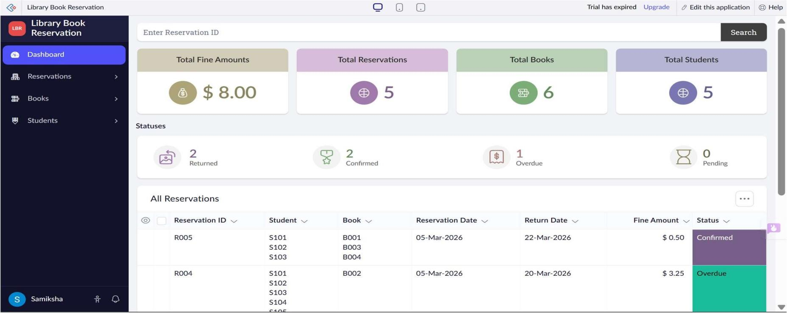
Output:

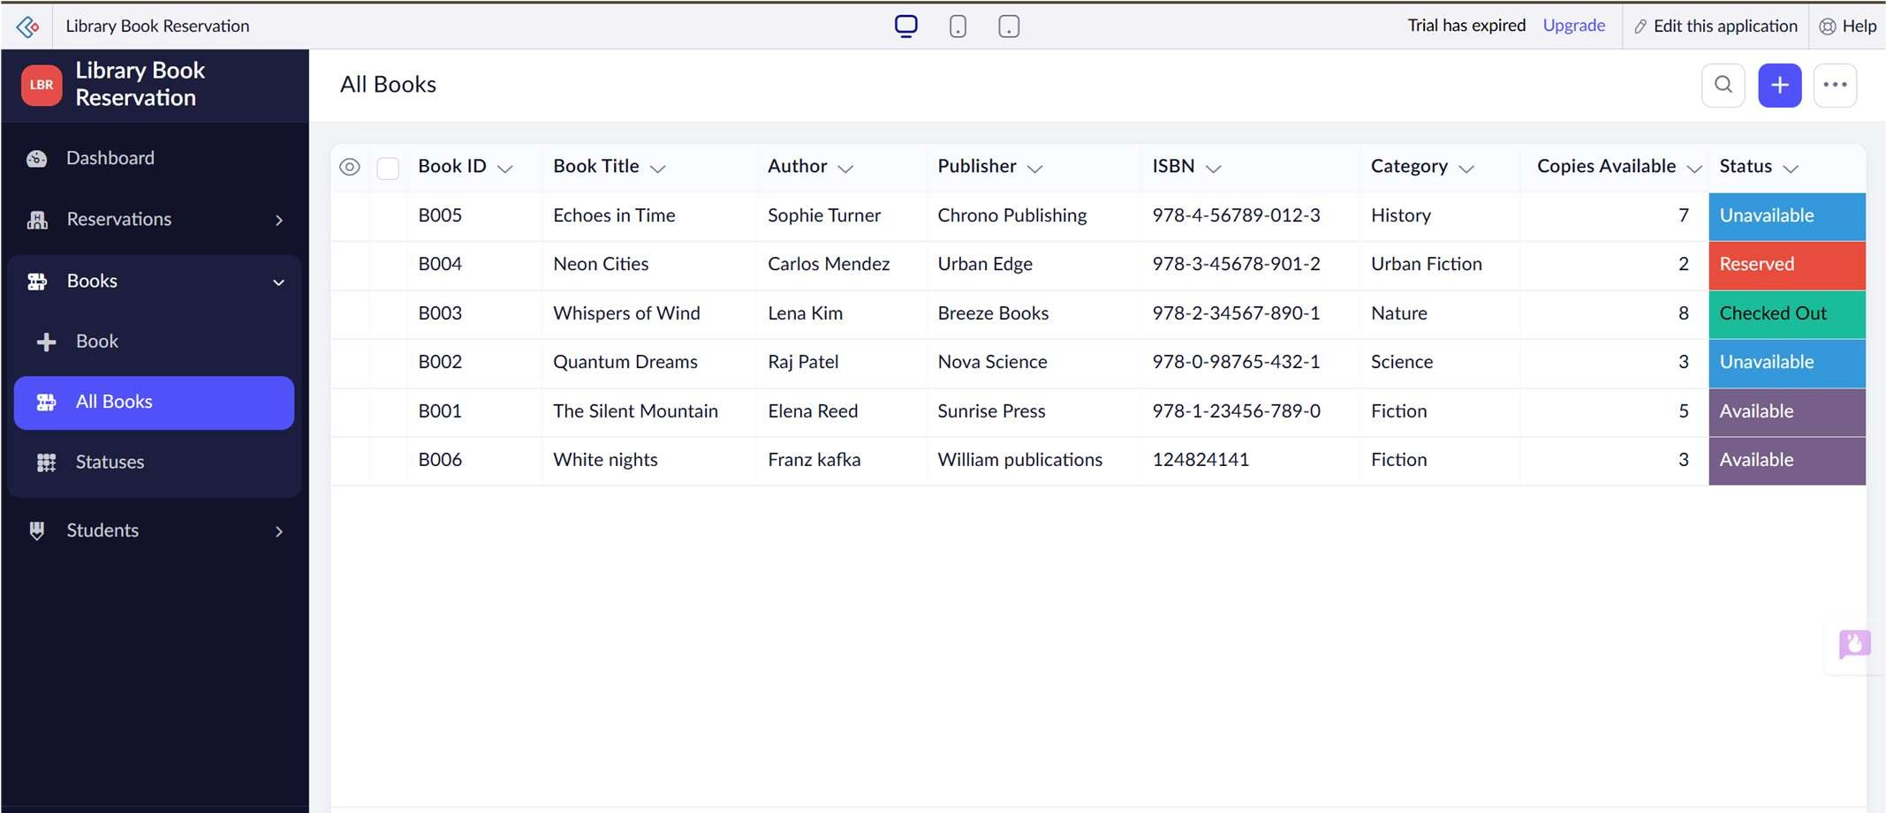
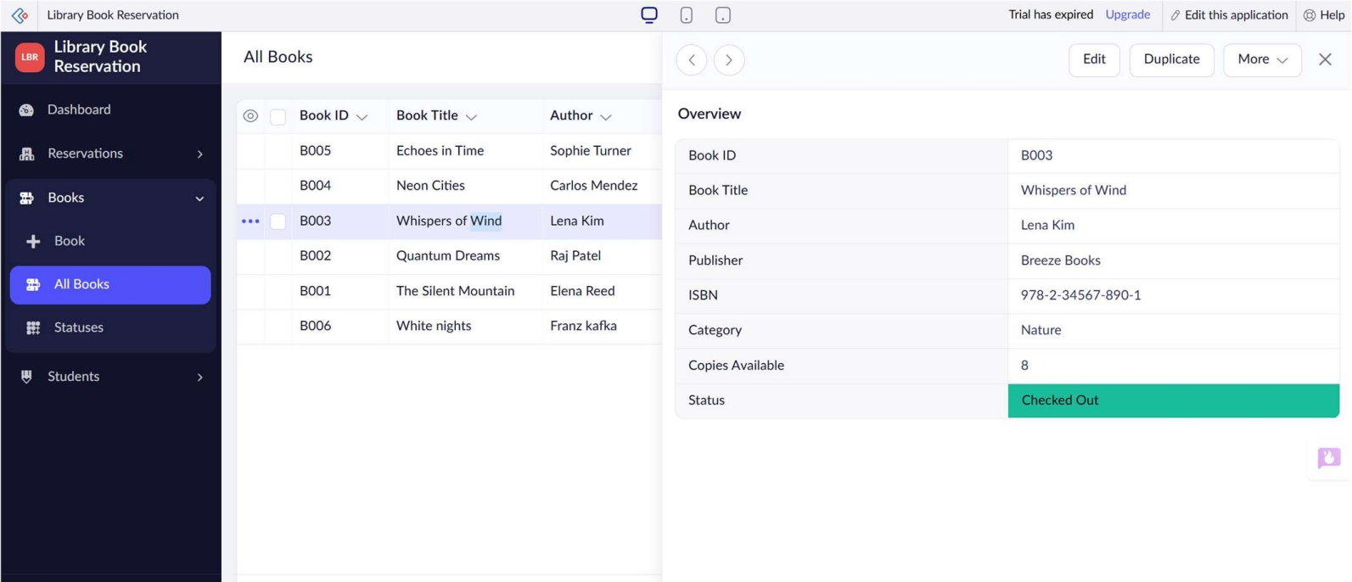

Result
Thus, a cloud-based Library Book Reservation System was successfully created and deployed as a SaaS application. The application allows users to manage book details and reservation status through a web interface.

Experiment 2: Create a simple cloud software application for Payroll Processing System using any Cloud Service Provider to demonstrate SaaS include the necessary fields such as Name of the employee, experience in present org , over all experience, basic pay, HRA, DA, TA, net pay, gross pay etc.

Aim
To create a simple cloud-based Payroll Processing System using a Cloud Service Provider to demonstrate the Software as a Service (SaaS) model.

Procedure
- Select a Cloud Service Provider such as Google Cloud, Microsoft Azure, or AWS.
- Create a new cloud application named Payroll Processing System.
- Create a database/table for storing employee payroll information.
- Add the following fields:
- Employee Name
- Experience in Present Organization
- Overall Experience
- Basic Pay
- HRA
- DA
- TA
- Gross Pay
- Net Pay
- Design a user interface to enter employee details.
- Define the payroll calculation:
- Gross Pay = Basic Pay + HRA + DA + TA
- Net Pay = Gross Pay − Deductions
- Enter employee information and salary components.
- Calculate the gross pay and net pay.
- Deploy the application on the cloud platform.
- Test the application using sample employee records
Output:
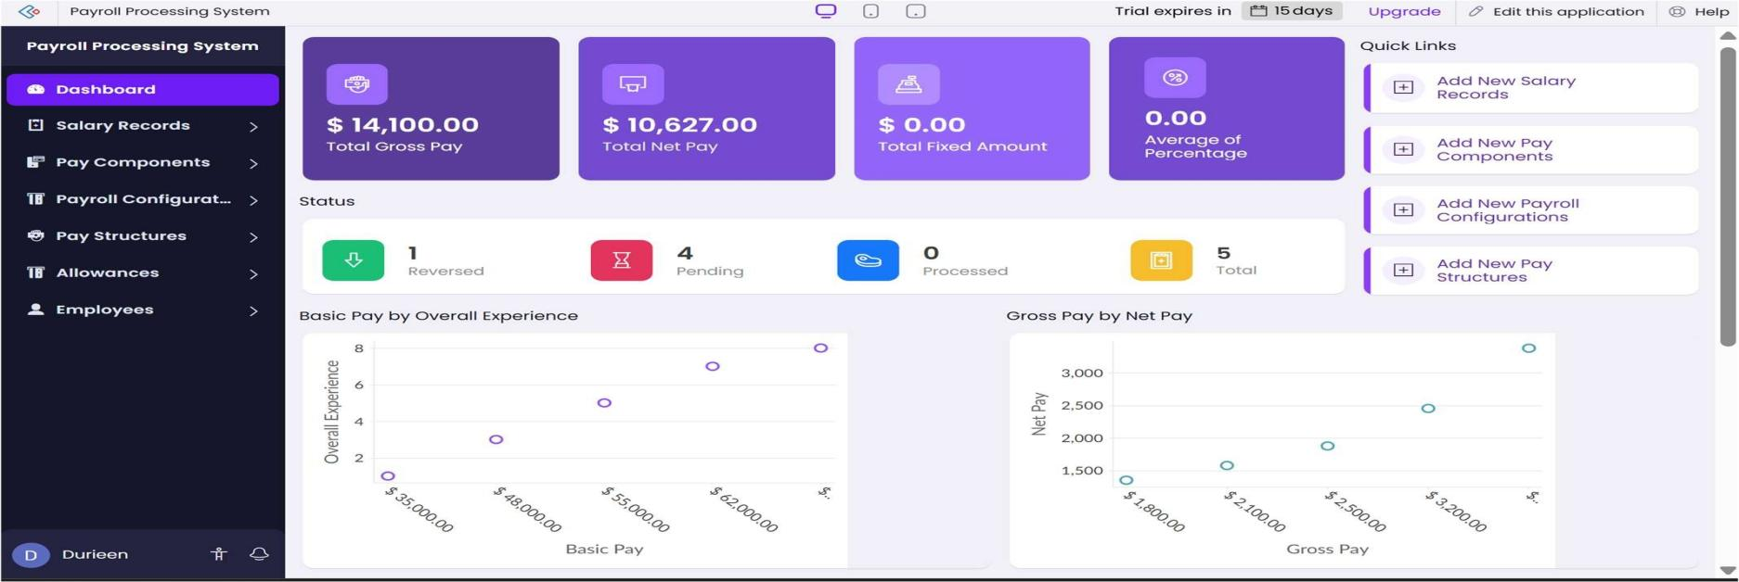
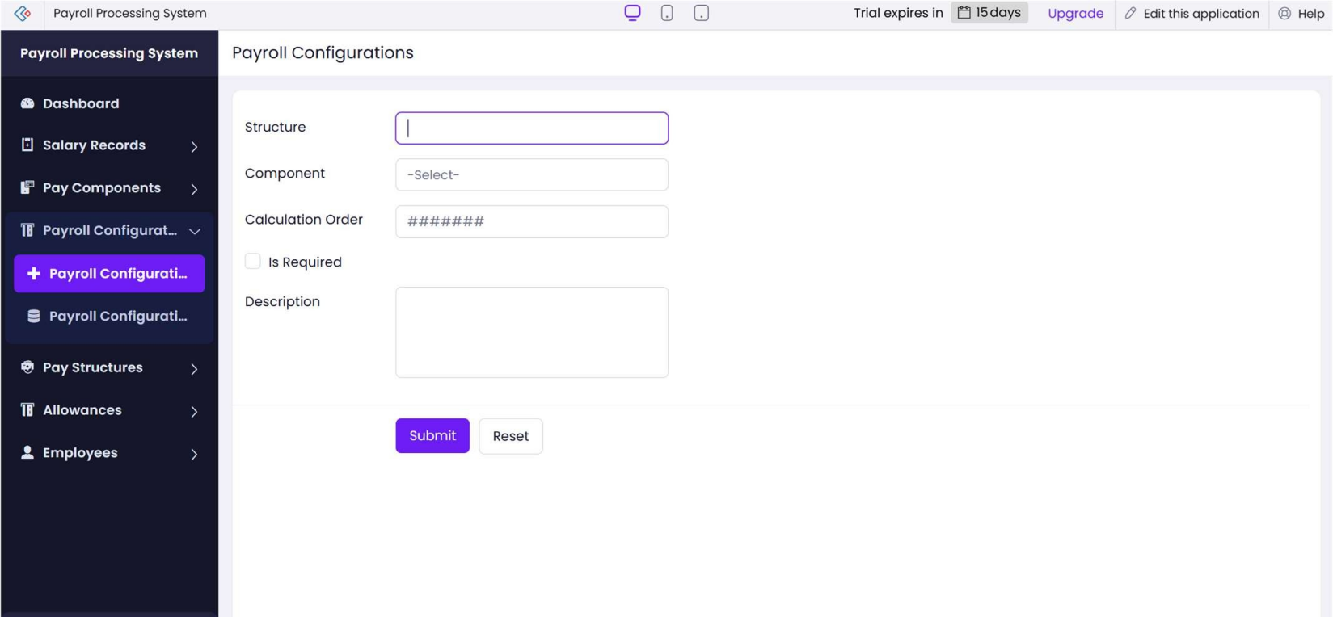

Result
Thus, a cloud-based Payroll Processing System was successfully created and deployed as a SaaS application. The system successfully stores employee details and calculates gross pay and net pay.
Experiment 3: Demonstrate virtualization by Installing Type-2 Hypervisor in your device, create and configure VM image with a Host Operating system (Either Windows/Linux). Create a Virtual Machine with 1 CPU, 2GB RAM and 15GB storage disk using a Type 2 Virtualization Software.

Aim
To demonstrate virtualization by installing a Type-2 Hypervisor and creating a Virtual Machine with 1 CPU, 2 GB RAM, and 15 GB storage.

Procedure
- Start the computer with the existing Host Operating System such as Windows or Linux.
- Download and install a Type-2 Hypervisor such as Oracle VirtualBox or VMware Workstation.
- Open the installed virtualization software.
- Click Create/New Virtual Machine.
- Enter a suitable name for the VM.
- Select the required Guest Operating System and its version.
- Allocate 1 CPU to the Virtual Machine.
- Allocate 2 GB RAM to the Virtual Machine.
- Create a virtual hard disk with 15 GB storage.
- Select the required disk type and create the virtual disk.
- Attach the Guest OS ISO image to the virtual optical drive.
- Start the Virtual Machine.
- Install the Guest Operating System.
- After installation, restart the VM and verify the configuration.
- Test the VM by opening applications and performing basic operations.
Output:
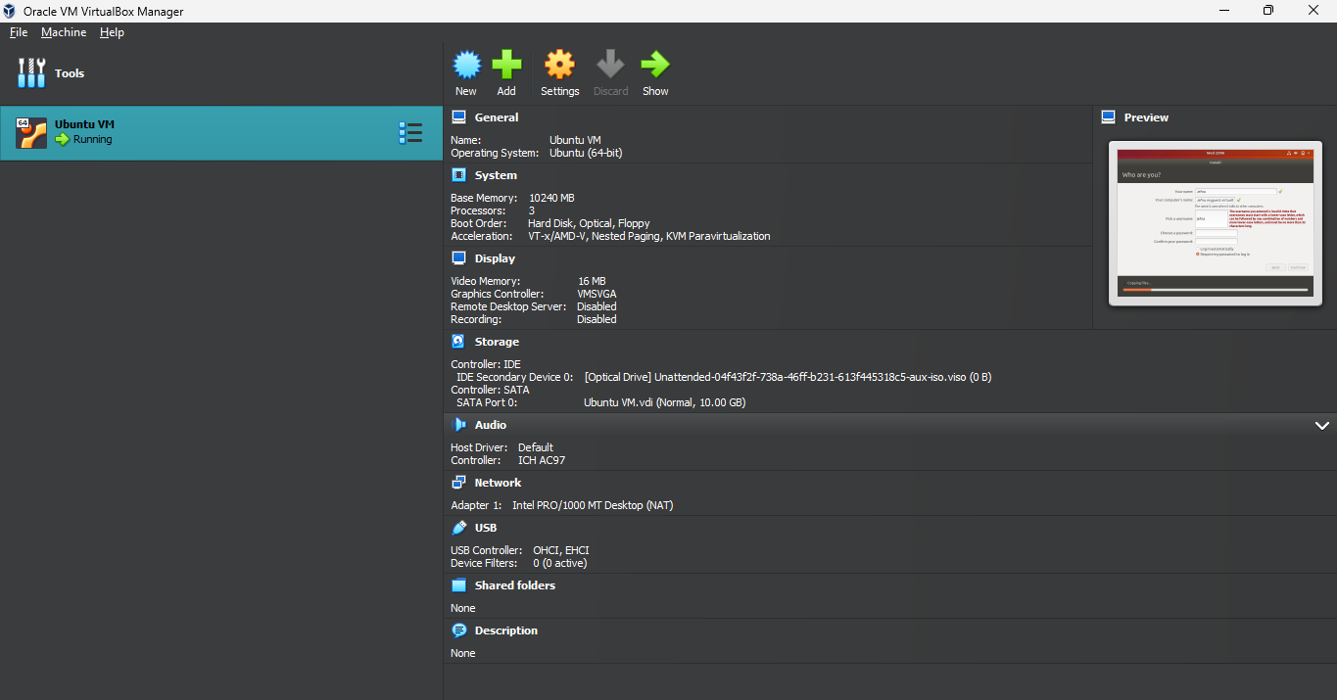

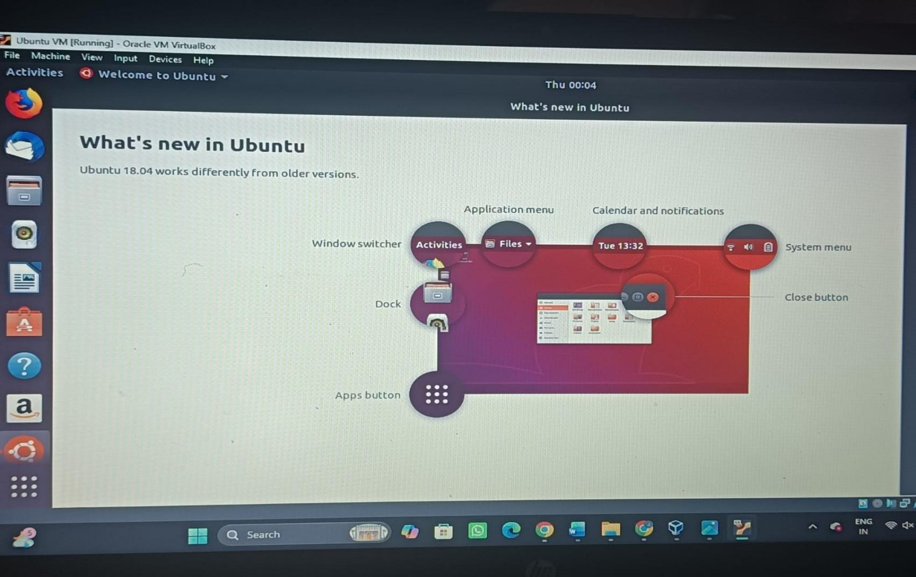

Result
Thus, a Virtual Machine was successfully created using a Type-2 Hypervisor with 1 CPU, 2 GB RAM, and 15 GB storage, and the Guest Operating System was successfully installed and executed.

Experiment 4: Demonstrate virtualization by Installing Type-2 Hypervisor in your device, create and configure VM image with a Host Operating system (Either Windows/Linux). Create a Cloning of a VM and Test it by loading the Previous Version/Cloned VM

Aim
To demonstrate virtualization by cloning an existing Virtual Machine using a Type-2 Hypervisor and testing the cloned VM by loading the previous version.

Procedure
- Open the installed Type-2 Hypervisor such as Oracle VirtualBox or VMware Workstation.
- Identify the previously created Virtual Machine.
- Shut down the original VM properly.
- Select the VM and choose the Clone option.
- Provide a suitable name for the cloned VM.
- Select the appropriate cloning option, such as Full Clone.
- Create the cloned VM.
- Verify that the cloned VM has its own virtual disk and configuration.
- Start the cloned VM.
- Verify that the Guest Operating System loads successfully.
- Check the files, applications, and settings available in the cloned VM.
- Perform basic operations to verify that the cloned VM works independently.
- Compare the original VM and cloned VM to verify that the previous environment has been replicated.
Output:
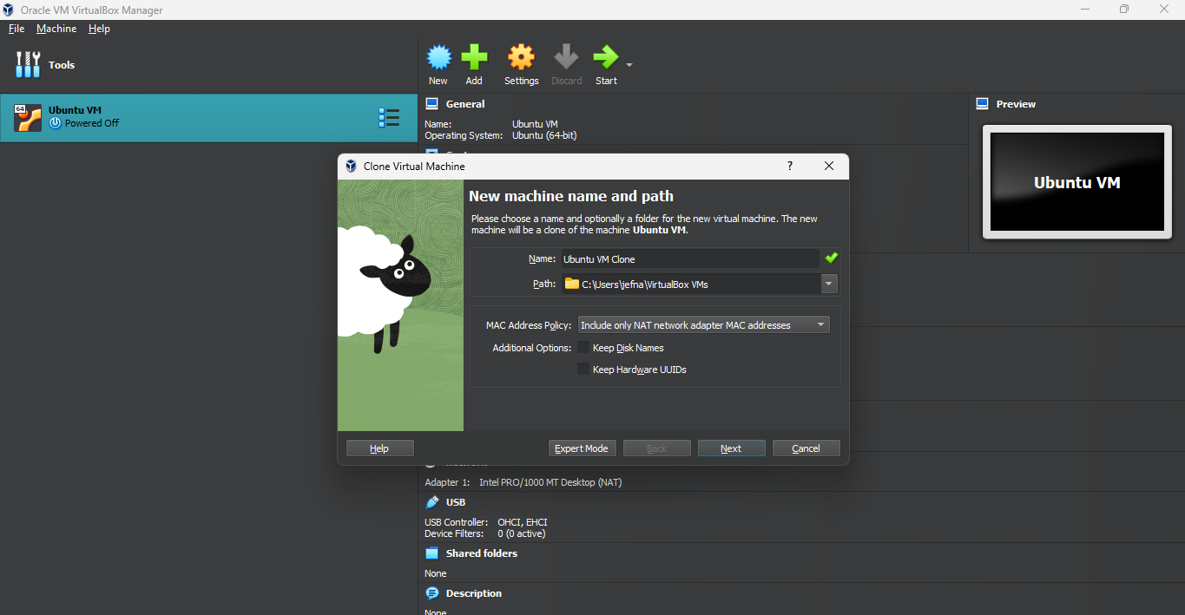
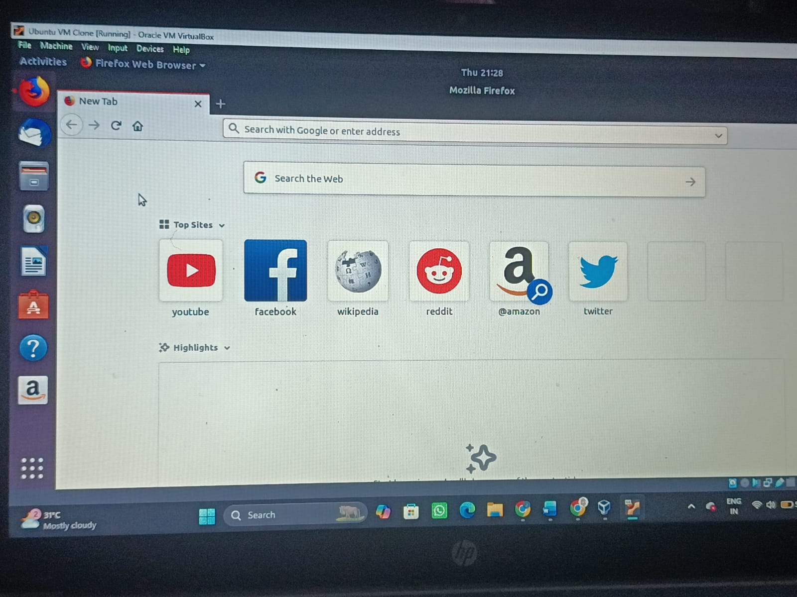

Result
Thus, the existing Virtual Machine was successfully cloned using a Type-2 Hypervisor. The cloned VM was started and tested successfully, and the previous operating system environment, files, and configurations were available in the cloned VM.

